**User Manual**

**Module - Hotel Management System**

**June 2022, Version-1.0**



**Sustainable Outreach and Universal Leadership Limited**

**Sign off Date     Signature Client Signature Consulting**

Table of Contents

[Module: Hotel 3](https://docs.google.com/document/d/198pC5pz8fhu2hql7Lhit7WpfHo7yllOk/edit" \l "heading=h.1fob9te)

[1. Hotel 3](https://docs.google.com/document/d/198pC5pz8fhu2hql7Lhit7WpfHo7yllOk/edit" \l "heading=h.3znysh7)

[2. Hotel Room](https://docs.google.com/document/d/198pC5pz8fhu2hql7Lhit7WpfHo7yllOk/edit" \l "heading=h.2et92p0) 4

[3. Hotel Room Package](https://docs.google.com/document/d/198pC5pz8fhu2hql7Lhit7WpfHo7yllOk/edit" \l "heading=h.tyjcwt) 5

[4. Hotel Room Pricing 6](https://docs.google.com/document/d/198pC5pz8fhu2hql7Lhit7WpfHo7yllOk/edit" \l "heading=h.3dy6vkm)

1. [Hotel Room Reservation 7](https://docs.google.com/document/d/198pC5pz8fhu2hql7Lhit7WpfHo7yllOk/edit" \l "heading=h.1t3h5sf)
2. [Hotel Room Type](https://docs.google.com/document/d/198pC5pz8fhu2hql7Lhit7WpfHo7yllOk/edit" \l "heading=h.1t3h5sf) 8
3. Hotel Settings 9

**Hotel Module**

In Hotel Module we have two different user:

1. Hotel Manager
2. Hotel Reservation User

Hotel Manager has th permission to use all the doctypes and can access and transact in all. But the Hotel Reservation USer has only access to Hotel Room Reservation doctype through which they can book hotel rooms at the reception desk for the guests.

1. **Hotel**

Restaurant is a master doctype where you add hotel and its respective address.

**1.1 To access the Sales Invoice list, go to:**

Home > Hotel Management > Your Shortcuts > Hotel

**1.2 How to Create a Hotel?**

1. Go to Hotel and Click on Add Hotel.
2. Save.

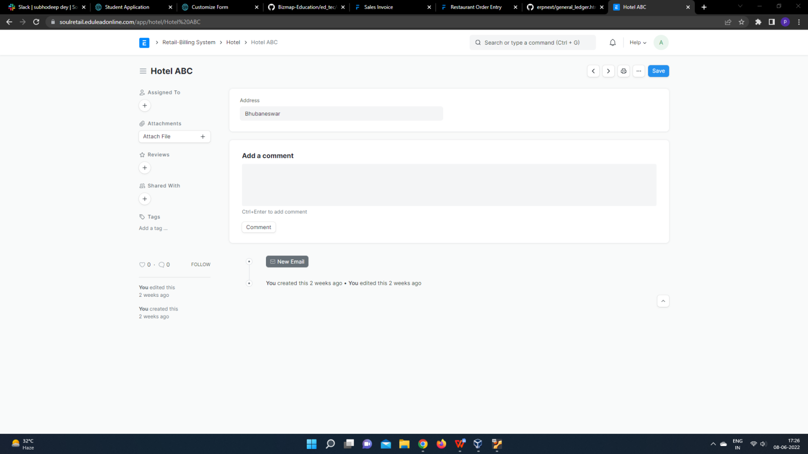

1. **Hotel Room**

In Hotel Room you can declare the room type along with its total capacity and if any extra bed can added to that room or not.

**2.1 To access the Sales Invoice list, go to:**

Home > Hotel Management > Your Shortcuts > Hotel Room

**2.2 Prerequisite**

* Hotel Room Type.

**2.3 How to Create a Hotel Room?**

1. Go to Hotel Room and Click on Add Hotel Room.

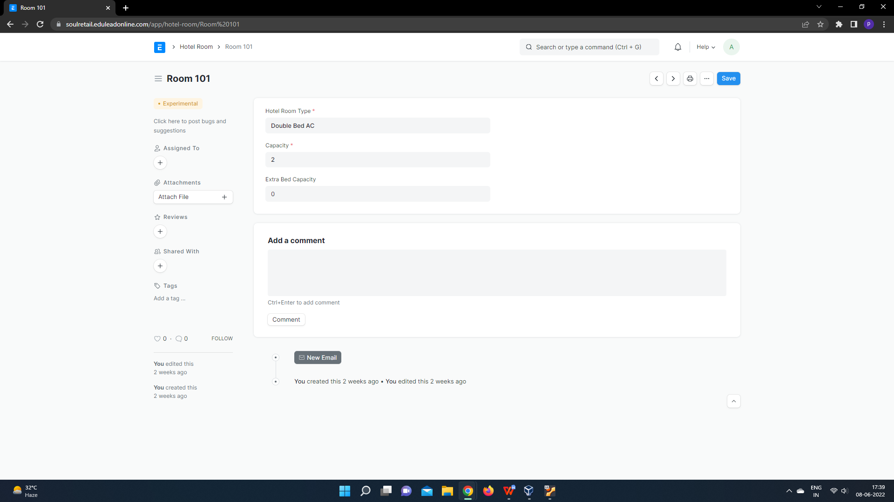

1. Enter Room name, Hotel Room Type, Capaity, Extra bed capacity.
2. Save.
3. **Hotel Room Package**

In Hotel Room Package you can add Items/ Amenities that would be included with a particular Hotel Room.

**3.1 To access the Sales Invoice list, go to:**

Home > Hotel Management > Your Shortcuts > Hotel Room Package

**2.2 Prerequisite**

* Hotel Room Type.

**3.3 How to Create a Hotel Room Package?**

1. Go to Hotel Room Package and Click on Add Hotel Room Package.

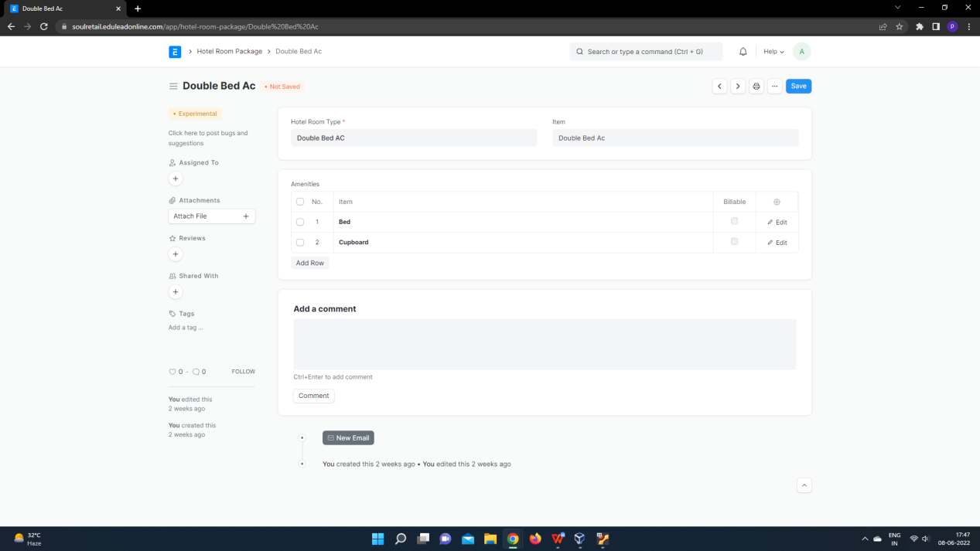

1. Enter Hotel Room Package name, Hotel Room type, Item that you want to add in the particular room type inside that package.
2. Check Billable checkbox if that item is to be billed.
3. Save.

### 4.**Hotel Room Pricing**

In Hotel Room Pricing you can declare Pricing for Hotel Room for a specific range of dates.

**4.1 To access the Sales Invoice list, go to:**

Home > Hotel Management > Your Shortcuts > Hotel Room Pricing

**4.2 Prerequisite**

* Hotel Room Package.

**4.3 How to Create a Hotel Room Pricing?**

1. Go to Hotel Room Pricing and Click on Add Hotel Room Pricing.

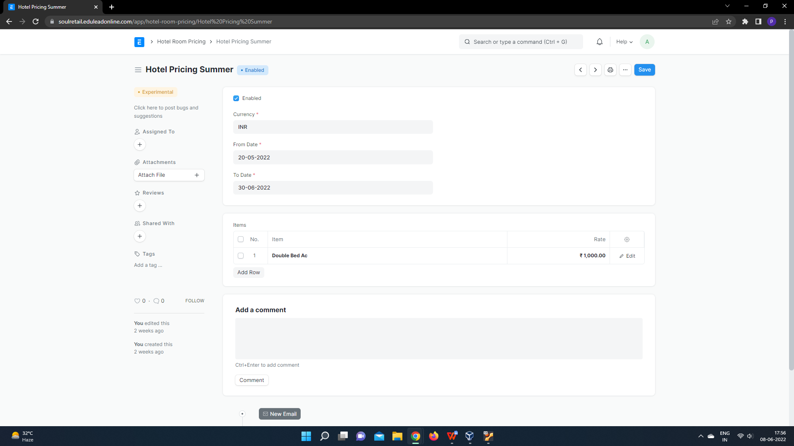

1. Select Currency, From date, to date.
2. Add Room Type and add rate for that room during the date selected.
3. Save.

### **Hotel Room Reservation**

In Hotel Room Pricing you can declare Pricing for Hotel Room for a specific range of dates.

**5.1 To access the Sales Invoice list, go to:**

Home > Hotel Management > Your Shortcuts > Hotel Room Reservation

**5.2 Prerequisite**

* Hotel.
* Hotel Room Pricing.
* Hotel Room Package.

**5.3 How to Create a Hotel Room Reservation?**

1. Go to Hotel Room Reservation and Click on Add Hotel Room Reservation.

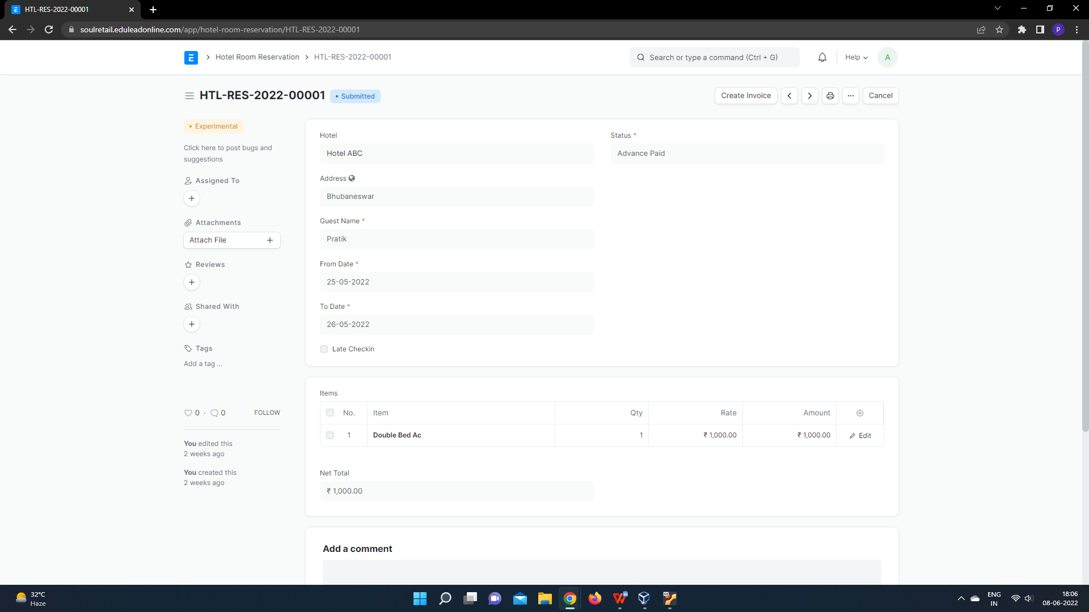

1. Select Hotel, Add Guest name, From Date, to date.
2. Add Room type based on which rate of room will be auto fetched, we need to enter total no of rooms needed.
3. Based on the details entered Net Total will be calculated.
4. Save.

**6.Hotel Room Type**

In Hotel Room Type you enter the room type, its capacity and amenities associated with it.

**6.1 To access the Sales Invoice list, go to:**

Home > Hotel Management > Your Shortcuts > Hotel Room Type

**6.2 Prerequisite**

* Items

**6.3 How to Create a Hotel Room Type?**

1. Go to Hotel Room Type and Click on Add Hotel Room Type.

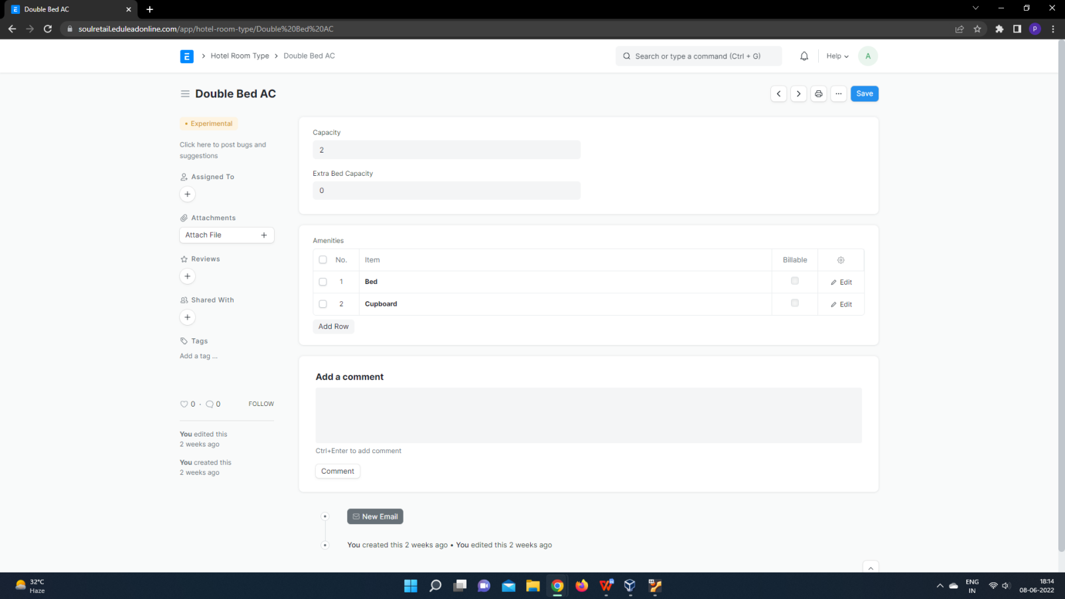

1. Enter Name of Room type, Capacity, Extra bed capacity.
2. Add Amenities for the particular room type, check billable if the amenity is billable.
3. Save.

**7.Hotel Settings**

In Hotel Settings you can set default Taxes and Charges and ndefault Invoice Naming Series.

**7.1 To access the Sales Invoice list, go to:**

Home > Hotel Management > Your Shortcuts > Hotel Settings

**7.2 Prerequisite**

* Taxes and Charges Template

**7.3 How to Create a Hotel Settings?**

1. Open Hotel Settings.

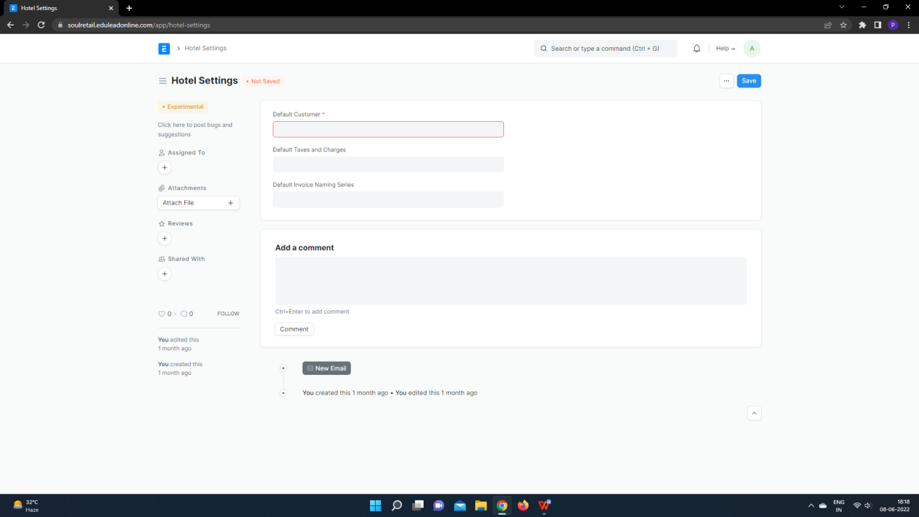

2. Select default Taxes and Charges and add default invoice naming series that you want in your invoice to be generated with.

3. Save.